A neuron in deep learning is a mathematical function inspired by a biological neuron.
Biological neuron:
- Receives signals
- Processes them
- Sends output
Artificial neuron:
- Takes inputs (numbers)
- Multiplies them with weights
- Adds bias
- Applies activation function
- Produces output
- Mathematical Representation of a Neuron
- If inputs are:
x₁, x₂, x₃
Each input has a weight:
w₁, w₂, w₃
Then neuron computes:
z = (w₁x₁ + w₂x₂ + w₃x₃) + b
output = activation(z)

What Are Weights?
Weights represent:
How important each input is.
If:
- Weight is large → input is important
- Weight is small → input has less impact
- Weight is negative → input reduces output

What is Bias?
Bias is an extra adjustable parameter.
Without bias:
Decision boundary must pass through origin.
With bias:
Model can shift decision boundary.
Think of bias as:
The intercept in linear regression.
It allows flexibility.

What is Activation Function?
Activation function decides:
Should neuron activate or not?
Without activation:
Whole network becomes linear.
Deep learning works because of non-linearity.

Complete Flow of One Neuron
Inputs (x₁, x₂, x₃)
↓
Multiply by weights
↓
Sum them
↓
Add bias
↓
Apply activation
↓
Output
y = f(∑ wᵢxᵢ + b)
A perceptron is the simplest artificial neuron used for binary classification. It computes a weighted sum of inputs, adds a bias term, and applies an activation function to produce an output. Weights determine the importance of inputs, bias shifts the decision boundary, and activation functions introduce non-linearity, allowing neural networks to learn complex patterns.
A Multi-Layer Perceptron (MLP) is a feedforward neural network with one or more hidden layers that learns complex nonlinear patterns by applying weighted sums and activation functions across multiple layers.
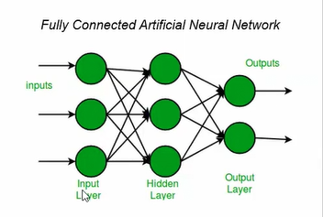
Architectures are the structural designs of neural networks that define how layers, neurons, and connections are arranged to process data.
An architecture specifies:
- How many layers
- What type of layers
- How they are connected
- How data flows through the network
Example architectures:
- MLP (fully connected layers)
- CNN (convolutional layers for images)
- RNN (sequential processing)
- Transformer (attention-based models used in LLMs)
- 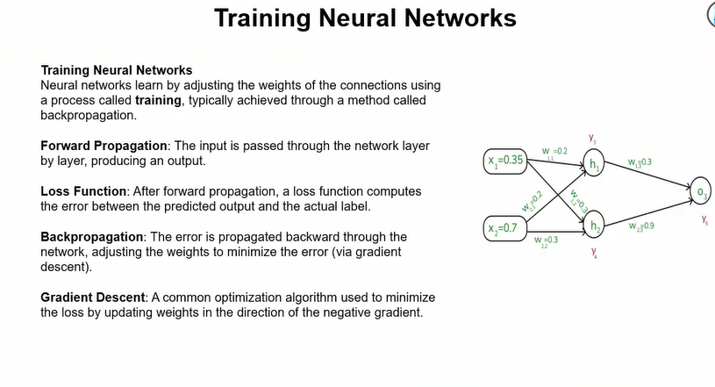
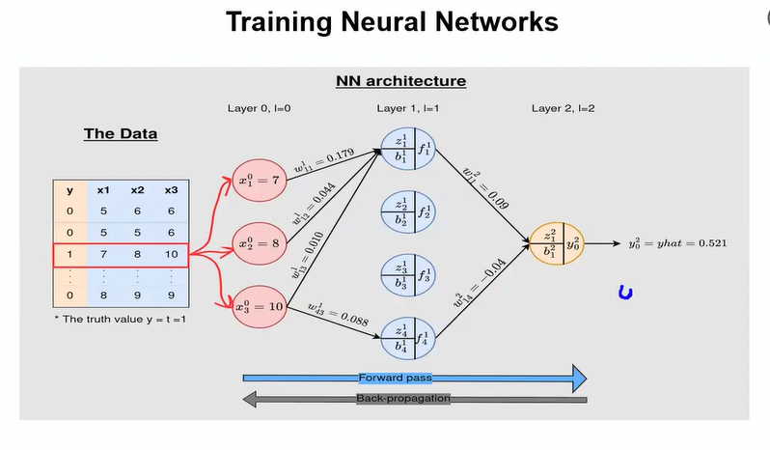

What is a Loss Function?
Loss function measures how wrong a model’s prediction is compared to the actual value.
In simple words:
Loss = Error between predicted output and true output.
The goal of training is:
Minimize the loss.

What is Mean Squared Error (MSE)?
Mean Squared Error is one of the most common loss functions used in regression problems.
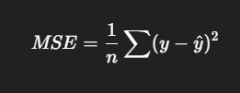
Why Do We Use Mean Squared Error?

Squaring Removes Negative Values
If we don’t square:
(5−3)=2(3−5)=−2(5 - 3) = 2 (3 - 5) = -2(5−3)=2(3−5)=−2
They cancel out when averaged.
Squaring ensures:
- All errors become positive.
- Large errors become larger.

Squaring Penalizes Large Errors More
Example:
Error = 1 → Squared = 1
Error = 5 → Squared = 25
Large mistakes are punished heavily.
This makes the model more careful.

It Is Smooth and Differentiable
MSE is:
- Continuous
- Differentiable
This is very important for Gradient Descent.
Because training requires derivatives:
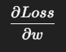
MSE makes backpropagation mathematically easy.

Intuition Example
Suppose actual house price = 100
Predicted price = 80
Error = 20
Squared error = 400
If prediction was 95:
Error = 5
Squared error = 25
Model will prefer second prediction because loss is smaller.
For classification we use:
- Cross Entropy Loss

Why Not Just Use Absolute Error?
Absolute error:
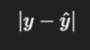
Problems:
- Not differentiable at 0
- Gradient is constant (doesn’t change smoothly)
MSE has smooth gradient → better optimization.
A loss function measures the difference between predicted and actual values. Mean Squared Error (MSE) is commonly used in regression because it squares errors to avoid negative cancellation, penalizes large errors more heavily, and is differentiable, making it suitable for gradient-based optimization.

Minimize the Loss
We want:
Find values of weights (w) that make loss as small as possible.
Loss depends on weights:
Loss=f(w)Loss = f(w)Loss=f(w)
So the question becomes:
How do we adjust w to reduce Loss?

Idea of Gradient Descent
Imagine you are standing on a mountain.
- Height = Loss
- Position = Weight value
Your goal:
Reach the lowest point (minimum loss).
How do you go downhill?
You check the slope.

What is Slope?
Slope tells us:
In which direction is the function increasing or decreasing?
Mathematically:
Slope = Derivative
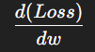
This derivative tells:
- If positive → loss increases as w increases
- If negative → loss decreases as w increases

Gradient Descent Update Rule
Once we know the slope, we update weight:
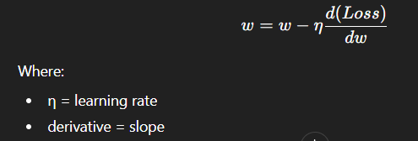

Simple Example (Step-by-Step)
Suppose:
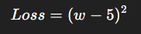
This is a parabola.
Minimum is at:
w=5
Step 1: Find derivative (slope)
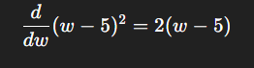

Step 2: Apply Gradient Descent
Update rule:
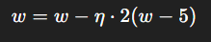

Step 3: Try values
Let:
- Initial w = 0
- Learning rate η = 0.1
Gradient:
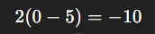
Update:
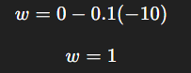
Next step:
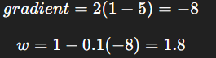
It keeps moving toward 5.
Eventually it converges near minimum.

What is Learning Rate (η)?
Learning rate controls step size.
If too small:
- Training very slow
If too large:
- May overshoot minimum
- May diverge
Choosing learning rate is important.
Gradient descent minimizes loss by computing the derivative (slope) of the loss function with respect to weights and updating the weights in the opposite direction of the slope to move toward the minimum.

